**RECOGNITION OF DIGITAL HARASSMENT ON WEB-BASED SOCIAL CHANNELS**

**ABSTRACT**

While social media offer great communication opportunities, they also increase the vulnerability of children to threatening situations online. Recent studies report that cyberbullying constitutes a growing problem among children. Successful prevention depends on the adequate detection of potentially harmful messages and the information overload on the Web requires intelligent systems to identify potential risks automatically.Online predators try to gradually seduce their targets through attention, affection, kindness, and even gifts, and often devote considerable time, money and energy to this effort. They are aware of the latest music and hobbies likely to interest kids. They listen to and sympathize with kids' problems. They also try to ease young people's inhibitions by gradually introducing sexual content into their conversations or by showing them sexually explicit material. Here we have proposed solution will detect suspect profiles based on child grooming behavior patterns followers, hate speech provokers, stalking and bullying mentality profiles and explicit content explorers (postings, comments) on social media platforms and other websites.

**INTRODUCTION**

Web 2.0 has had a substantial impact on communication and relationships in today’s society. Children and teenagers go online more frequently, at younger ages, and in more diverse ways (e.g. smartphones, laptops and tablets). Although most of teenagers’ Internet use is harmless and the benefits of digital communication are evident, the freedom and anonymity experienced online makes young people vulnerable with cyberbullying being one of the major threats .Bullying is not a new phenomenon and cyberbullying has manifested itself as soon as digital technologies have become primary communication tools. On the positive side, social media like blogs, social networking sites (e.g. Facebook), and instant messaging platforms (e.g. WhatsApp) make it possible to communicate with anyone and at any time. Moreover, they are a place where people engage in social interaction, offering the possibility to establish new relationships and maintain existing friendships On the negative side however, social media increase the risk of children being confronted with threatening situations including grooming or sexually transgressive behavior, signals of depression and suicidal thoughts, and cyberbullying. Users are reachable 24/7 and are often able to remain anonymous if desired: this makes social media a convenient way for bullies to target their victims outside the school yard With regard to cyberbullying, a number of national and international initiatives have been launched over the past few years to increase children’s online safety.

The prevalence of cyber victimization depends on the conceptualization used in describing cyberbullying, but also on research variables such as location and the number and age span of the participants. Nevertheless, the above studies demonstrate that online platforms are increasingly used for bullying, which is a cause for concern given its impact., cyberbullying may negatively impact the victim’s self-esteem, academic achievement and emotional well-being. found that self-reported effects of cyberbullying include negative effects on school grades and feelings of sadness, anger, fear, and depression. In extreme cases, cyberbullying could even lead to self-harm and suicidal thoughts.

**SYSTEM ANALYSIS**

**EXISTING SYSTEM**

There exists various child predator detection system which are used in gaming, audio chat and in various online entertainment platform. While playing games or for using online audio chat there exists a child predator system which detects an online sexual harassment and prevent child from getting abused or getting harassed by sexual predator as this existing system is only used when the children are playing games on internet or doing any audio chats. As now we are in internet era various children are now days using social media platform for various social activities. They are mostly active on social media so to prevent child harassment we need a child predator detection system for social media.

**DISADVANTAGES OF THE EXISTING SYSTEM**

* Complexity and Resources
* Evading Detection

**PROPOSED SYSTEM**

We propose a system for child predator detection system. We implementing 3 Modules for the detection system. User Module (Child/Predator) Training Module Cyber System Function of System User Module: In this project we will show two types of user. First normal user another type showing predator behavior. Training Module: In training Module we are using SVM algorithm for text classification and image detection. After Training Module, we will send predator report to cyber admin. Cyber System: Checking all predator report and taking action according to that report.

**ADVANTAGES OF PROPOSED SYSTEM**

* Early Intervention
* Safer Online Spaces
* Protection of Privacy

**SYSTEM ARCHITECTURE**

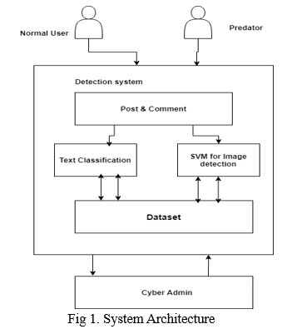

**SYSTEM REQUIREMENTS**

**HARDWARE REQUIREMENTS**

* Hardware : Pentium Dual Core
* Hard Disk : 20 GB.
* Speed : 2.80 GHz
* RAM : 1 GB

**SOFTWARE REQUIREMENTS**

* Operating System : Windows 10
* Technology : Java 8 and J2EE
* Web Server : Tomcat
* Web Technologies : HTML, CSS, JavaScript
* Data Base Server : MySQL
* IDE : Netbeans

**MODULES**

* Admin.
* User.